Braille Bootcamp
Participant Manual
Christa H. Miller
Stephanie E. Compton
June 21st, 2019
Blacksburg, Virginia 24061

Contents

1 Learning Braille

2 English Braille American Edition vs Unified English Braille
2.1 The adoption of Unified English Braille
2.2 UEB highlights

3 Braille Alphabet and Numbers
3.1 General Formatting
3.2 Grade 1 (uncontracted)
3.3 Numbers
3.4 Grammar
3.5 Braille Only Markings

4 Nemeth Code Braille
4.1 History
4.2 Nemeth Numbers
4.3 Punctuation
4.4 Signs of Operation
4.5 Signs of Comparison
4.6 Single Alphabetic Variables

5 Contractions
5.1 Alphabetic word signs
5.2 Non-alphabetic Whole Word Contractions

6 Braille Transcription Basics

Agenda

Time | Item
8:00 AM | Welcome and Introduction to Braille
8:15-10:00 AM | Rotation 1: Braille Alphabet
10:00-10:15 AM | Break and Quiz 1
10:15-11:00 AM | Rotation 2: Braille Numbers
11:00-11:15 AM | Break and Quiz 2
11:15-12:00 PM | Rotation 3: Grammar
12:00-1:00 PM | Lunch
1:00-1:45 PM | Rotation 4: Nemeth Numbers and Punctuation
1:45-2:00 PM | Break and Quiz 3
2:00-2:45 PM | Rotation 5: Nemeth Operations & Comparisons
2:45-3:00 PM | Break and Quiz 4
3:00-3:45 PM | Rotation 5: Alphabetic Word Signs and Contractions
3:45-4:00 PM | Awards and Wrap up.

Table 1: Braille Bootcamp Agenda

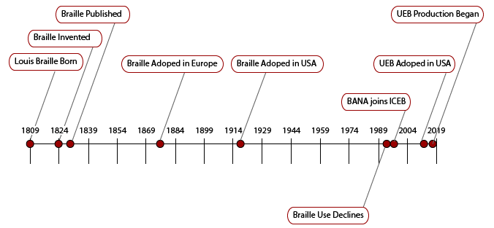
Chapter 1
Learning Braille
Figure 1: Brief timeline of key events in the history of Braille adoption

Braille is named after its creator, Louis Braille, born in 1809 in Coupvray, France, just southeast of Paris. Louis became blind as the result of a childhood accident, and as a young man he was bright, creative, and diligent. This led to his admission into one of the first schools for the blind, the National Institute for Blind Youth in Paris founded in 1784.
The school had very few books and the ones they did have were extremely expensive to make and difficult to read. They consisted of raised print characters and out of necessity contained very little information. Although the challenges of creating and using these books could have brought literacy for the blind to a halt, it actually paved the way for literacy by choosing touch as the primary means of communication.
While he was in Paris, Louis learned about a military code of communication called “night writing" that was based on using raised dots to communicate silently and without light on the battlefield. The system had been devised by Captain Charles Barbier who gladly shared it with Louis. Unfortunately, the system as it was originally designed was cumbersome. Louis, determined to find a way to bridge the communication gap for the blind, set about adapting it into his own system of raised dots.
Louis completed the original code for reading, writing and math in 1824 at age 15. His passion for music led him to expand the code and create an extension of his system for reading and writing music. He published his music code in 1829. Although he was much admired and respected for his work, his system of reading and writing was not adopted until after his death even at the National Institute for Blind Youth in Paris where he became an instructor.
Braille spread throughout France, but was slow to spread elsewhere. It was not until 1873, at the first conference for teachers of the blind, that the Braille system was pushed as a means of communication for the blind. After this, Braille use spread rapidly throughout Europe. The United States was slow to adopt Braille, but finally relented in 1916 and the first edition of the American English Braille code was formalized in 1932.
In the United States the Braille Authority of North America (BANA) is responsible for maintaining the codes that govern Braille transcription and sometimes collaborates with the Canadian Braille Authority (CBA). BANA is comprised of representatives from the following organizations:
- American Council of the Blind, Inc. (ACB)
- American Foundation for the Blind (AFB)
- American Printing House for the Blind (APH)
- Associated Services for the Blind (ASB)
- Association for Education & Rehabilitation of the Blind & Visually Impaired (AER)
- Braille Institute of America (BIA)
- California Transcribers & Educators for the Blind and Visually Impaired (CTEBVI)
- CNIB (Canadian National Institute for the Blind)
- The Clovernook Center for the Blind (CCBVI)
- National Braille Association, Inc. (NBA)
- National Braille Press (NBP)
- National Federation of the Blind (NFB)
- National Library Service for the Blind and Physically Handicapped of the Library of Congress (NLS)
Although this list does not include every interested party, it is a nationally representative group of agencies that support Braille readers across the United States. The websites for these organizations often contain useful transcribing information and up-to-date information about how Braille is changing. For example, information about becoming a certified Braille transcriber can be found at the NFB.

Chapter 2
English Braille American Edition vs Unified English Braille

2.1 The adoption of Unified English Braille
In 1991 BANA received complaints about the steady decline in Braille usage among both children and adults. The most common reason cited was the complexity and organization of the Braille code, which resulted in the decision to completely overhaul the code. At that time, none of the English language Braille codes were the same and in 1993 BANA joined the international effort to develop a single Braille code for all English speaking countries. The Unified English Braille Code (UEB) was adopted by BANA as the official Braille code for the United States in 2012. No change is instantaneous, however. After a staged 4 year transition, UEB became the de facto standard for Braille production in 2016.
In transitioning to UEB, much of the code base from English Braille American Edition (also referred to as contracted Braille) was retained. For example, the dot configurations for the letters of the alphabet have not changed and most of the whole word contractions remain the same. However, significant changes to the text formatting rules, the symbology, and the integration with Nemeth Code Braille for Science and Mathematics (Nemeth) have made many experienced Braille readers slow to adopt the newer code.
Adoption rates aside, there are several benefits to UEB worth mentioning.
  - Reduces complexity for Braille transcriptionists who are producing standard literary Braille
  - Fewer complexities that cause transcription errors when using Braille transcription software
  - Increases ability to share Braille transcriptions internationally

2.2 UEB highlights
In the tables that follow, you will find a selection of the UEB code changes for reference.

To Translate | Print Character | Contracted | UEB
Transcriber’s Note | NA | , ' , ' | @.< @.>
Table 2: Transcriber’s Note Symbol in UEB

To Translate | Print Character | Contracted | UEB
single end quote | ’ | '4 | ,0
dash | – | - | ,-
long dash | — | -- | ",-
ellipse | ... | ,,, | 444
Table 3: Grammatical Markings in UEB
To Translate | Print Character | Contracted | UEB
dollar | $ | [ | ,s
percent | % | 3p | .0
asterisk | * | 99 | "9
Parentheses | ( ) | 77 | "< ">
square bracket | [ ] | ,7 7' | .< .>
curly bracket | { } | ;7 7; | _< _>
Table 4: Symbol Changes in UEB
To Translate | Print Character | Contracted | UEB
italic word | single word | . | .1
italic passage | two or more | .. . | .7 .'
bold word | single word | _. | ^1
bold passage | two or more | ,,_ _,' | ^7 ^'
Table 5: Formatting Changes in UEB

Chapter 3
Braille Alphabet and Numbers
All Braille characters are made up of six dots regardless of the reader’s primary spoken language. The dots are organized into two columns and three rows. Each dot is given a number, the top left dot being number 1, and from there the dots are numbered down each column in numerical order. This makes communicating individual Braille characters easier and allow Braille characters to be referenced by their dot configurations. Each dot is referenced by number as shown in the figure 2.

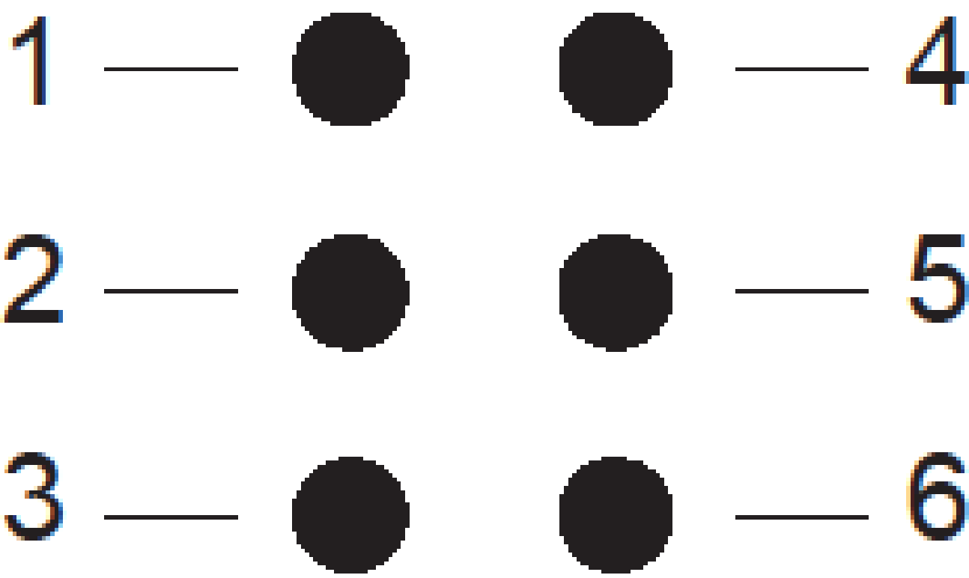

Figure 2: Each Braille character consists of six dots organized in two columns and three rows

Throughout this manual, Braille characters will be referenced by their numbered dot configuration.

3.1 General Formatting
The success of Braille is in its consistency. Even after nearly 200 years, the code continues to maintain its structure and integrity. For example, Braille that is printed (embossed) is produced with a maximum 40 Braille characters per line and 25 lines per page. If front and back embossing is desired, then interpoint is selected from the embossing options.
During the course of the drills, you will be expected to follow those guidelines. In the early drills, writing drills will be preset to use exactly 40 characters per line. This includes spaces which can be considered a “blank” or “empty” Braille cell. The reading drills have been preset to 20 Braille characters because of the 8.5x11 paper width.

Standard Braille uses 40 characters per line, 25 lines per page

3.2 Uncontracted (Grade 1)
Grade 1 Braille, also called uncontracted, is a letter by letter representation of print characters and the dot configurations are the same in both EBAE and UEB. It is tempting to think of Braille as another language, but it is actually more appropriate to think of it as another alphabet with a unique grammar. An excellent example of this is capital letters. In the English alphabet, there are 52 uniquely drawn characters when you consider both the uppercase and lowercase letters. In Braille there are only 26 alphabetic characters and a single capitalization indicator.
To begin with, the Braille alphabet follows a logical, progressive pattern. The first 10 characters are the base we will build upon. In the print edition we will use simulated Braille where the raised dots are bold and the un-raised dots are small. The first ten letters of the alphabet are:

Letter | Braille Representation | Dot configuration
a | ⠁ | dot 1
b | b | dots 1-2
c | c | dots 1-4
d | d | dots 1-4-5
e | e | dots 1-5
f | f | dots 1-2-4
g | g | dots 1-2-4-5
h | h | dots 1-2-5
i | i | dots 2-4
j | j | dots 2-4-5
Table 6: A-J English Braille Alphabet
Drill 1. ___________________________ Write It __________________________________
Write the following words in Braille.

cab dab had jig gad fade fad egg high ad
fed big jibe bad hi ace dig cage if face
___________________________________________________________________________

Drill 2. ___________________________ Read It __________________________________
Write the following words in Print.

cafe babe acade egad
deface beef age iced
a fee dice jade high
___________________________________________________________________________

The next ten letters of the alphabet are created by adding dot 3 to the first ten letters as shown here:
k l m n o p q r s t

Letter | Braille Representation | Dot configuration
k | k | dots 1-3
l | l | dots 1-2-3
m | m | dots 1-3-4
n | n | dots 1-3-4-5
o | o | dots 1-3-5
p | p | dots 1-2-3-4
q | q | dots 1-2-3-4-5
r | r | dots 1-2-3-5
s | s | dots 2-3-4
t | t | dots 2-3-4-5
Table 7: K-T English Braille Alphabet
Drill 3. ___________________________ Write It __________________________________
Write the following words in Braille.

slots lost rook stop noon not knoll look
most pomp loom knot moor storm torn room
___________________________________________________________________________

Drill 4. ___________________________ Read It __________________________________
Write the following words in Print.

nook slot posts root
morn moons tort torn
solo loss rooms knot
___________________________________________________________________________

The logical pattern continues by adding dot 6 to the second set of 10 characters of the alphabet. The one exception is the letter ‘w’. When Louis Braille developed his literacy system for the blind the letter ‘w’ was not part of the French alphabet. Thus the Braille dot configuration for ‘w’ was added at a later date.
u v w x y z

Letter | Braille Representation | Dot configuration
u | u | dots 1-3-6
v | v | dots 1-2-3-6
x | x | dots 1-3-4-6
y | y | dots 1-3-4-5-6
z | z | dots 1-3-5-6
w | w | dots 2-4-5-6
Table 8: U-Z English Braille Alphabet
Drill 5. ___________________________ Write It __________________________________
Write the following words in Braille.

vexed waxy zero bundt under woven lulled
xebec exit vote zoo fixed blaze worn yak
___________________________________________________________________________
Drill 6. ___________________________ Read It __________________________________
Write the following words in Print.

yolk swig wombat lox
swoon lovely mix why
swan wizened pew nix
___________________________________________________________________________

All together it looks like:

Line | Characters | Braille Representation
1 | A to J | a b c d e f g h i j
2 | K to T | k l m n o p q r s t
3 | U to Z | u v w x y z
Table 9: Complete English Braille Alphabet
BONUS
If time permits you are encouraged to complete the bonus drills.

Drill 7. _____________________ Write It - BONUS ________________________
Write the following words in Braille.

bad beef bide cadge cab lice decide free
deface die egg mole fife feet goes stone
fig gab exit hide idea ice jade jigs joy
badge decide beg dad dig when abide acid
farce quick bad beef dances jib home bed
___________________________________________________________________________

Drill 8. _____________________ Read It - BONUS ________________________
Write the following words in Print.
cornice empire italian clock
ridge work
comes thoroughness
pretty blue anemone in water
an unbelievably quiet poodle
___________________________________________________________________________

3.3 Numbers
Louis Braille also included numbers as part of his original system. For efficiency, the numbers are represented by the first ten letters of the alphabet preceded by a new Braille character the number indicator, not unlike the capitalization character. The Braille number character is dots 3-4-5-6 and is used once at the beginning of a number. These are literary numbers and can be used for everything that is not mathematical or scientific. For math and science contexts, we will use Nemeth Code Braille, which is covered in Chapter 4.
As a quick recap, our Braille alphabet for a-j is:
Characters | Braille Representation
A to J | a b c d e f g h i j
Table 10: A-J English Braille Alphabet
If we put the number indicator in front of each character we get:

Characters | Braille Representation | Number | Braille Representation
a | a | 1 | #a
b | b | 2 | #b
c | c | 3 | #c
d | d | 4 | #d
e | e | 5 | #e
f | f | 6 | #f
g | g | 7 | #g
h | h | 8 | #h
i | i | 9 | #i
j | j | 0 | #j
Table 11: Braille Literary Numbers
Drill 9. ___________________________ Write It __________________________________
Write the following in Braille.

56 pigs dug 73 holes in 9 garden beds
he ate 150 pickled peppers in 26 meals
1000 ridges on 48 mountains in 8 days
___________________________________________________________________________

Drill 10. ___________________________ Read It __________________________________
Write the following in Print.

#hce pages #b dashes
traveling #ajj miles
laughter #hge times now
___________________________________________________________________________

You may have noticed that there were no decimal points or commas in our numerical representations. That’s because grammatical markings are next. And, thanks to UEB there are now fewer rules to memorize regarding numbers and grammatical markings. For example, when representing decimal values, we can now use the same Braille character as the period. Basic grammatical markings will be addressed in section 3.4

3.4 Grammar
With 6 dots that can be raised or lowered and only 26 letters in the alphabet, the remaining dot configurations can be assigned to grammatical markings and later to Grade 2 Braille contractions. Let’s start with the 6 most frequently used grammatical markings.

Punctuation | Braille Representation | Dot configuration
.  (period) | 4 | dots 2-5-6
?  (question mark) | 8 | dots 2-3-6
!  (exclamation point) | 6 | dots 2-3-5
,  (comma) | 1 | dots 2
;  (semi colon) | 2 | dots 2-3
:  (colon) | 3 | dots 2-5
Table 12: Punctuation
Drill 11. ___________________________ Write It __________________________________
Write the following sentences in Braille.

my naughty cow was locked in pen 3 too.
gabby and i ate 8 ice cream sandwiches.
12 hair stylists cut, curl, and tease.
___________________________________________________________________________

Drill 12. ___________________________ Read It __________________________________
Write the following sentences in Print.

#d red 1 wax candles 4
where are # b bells 8
she steps 2 he waits 4
you 3 work then play 6
___________________________________________________________________________

Now that you have the primary grammatical markings down, here are the remaining eight.

Punctuation | Braille Representation | Dot configuration
- (hyphen) | - | dots 3-6
– (dash) | ,- | dot 6, dots 3-6
’ (apostrophe) | ' | dot 3
...  (ellipse) | 444 | dos 2-5-6, dots 2-5-6, dots 2-5-6
( )  (parentheses) | "< "> | dots 2-3-5-6, dots 2-3-5-6
[ ]  (square brackets) | .< .> | dots 4-6, dots 1-2-6, dots 4-6, dots 3-4-5
“”  (quotes) | 8 0 | dots 2-3-6, dots 3-5-6
Table 13: Punctuation continued
Drill 13. ___________________________ Write It __________________________________
Write the following sentences in Braille.

well-- they could watch jackson's movies.
self-reliance or "independence" grows.
what... [coughing] it's strep throat?!
___________________________________________________________________________

Drill 14. ___________________________ Read It __________________________________
Write the following sentences in Print.

play ball",-or dance4
what's up with them8
seriously6 what now6
___________________________________________________________________________

3.5 Braille Only Markings
Probably the most important grammatical marks in Braille are not grammatical marks in print. In print we essentially use 2 alphabets, an uppercase alphabet and a lower case alphabet. In Braille we do not have an uppercase alphabet, instead we have a capitalization indicator and using two together makes the ALL CAPS indicator.

Indicator | Braille Representation | Dot configuration
Capitalization | , | dot 6
All Caps | ,, | dot 6, dot 6
Table 14: Capitalization indicators
Drill 15. ___________________________ Write It __________________________________
Write the following sentences in Braille.

Hi my name is Erin Ho. What's yours?
Actor Ethan Shewl is a self-made man.
The new sign says: 25 percent SALES.
___________________________________________________________________________

Drill 16. ___________________________ Read It __________________________________
Write the following sentences in Print.

,See item ,No4 #dea4
,Yay6 ,We won chips4
,Aaron is an ,,INFP4

Note: In UEB there is one more capitalization notation for “passages" meaning more than one word in a row. We have not included any practice examples of it here.

Chapter 4
Nemeth Code Braille

4.1 Nemeth History
The most important code book for representing scientific information in the U.S. is the Nemeth Code book. Nemeth Code Braille was developed by Dr. Abraham Nemeth as a way to express more complicated mathematical and scientific concepts.
Dr. Nemeth was interested in studying mathematics during his undergraduate studies. However, his academic advisors discouraged him from it, believing it would be too difficult for him to understand the graphical components. It was also nearly impossible to obtain a math textbook in Braille at that time.
After completing a liberal arts degree, Dr. Nemeth went on to hold several jobs with organizations for the blind. Unfortunately he found these jobs dissatisfying and un-fulfilling. After a great deal of encouragement from his wife, he returned to graduate school to study mathematics.
It was during his graduate studies that he began to realize the great limitations of the existing Braille code when it came to representing more complex mathematical concepts. As a result he developed his own code of Braille for science and mathematics. The code was accepted in the United States in 1972 and several revisions have been made since then. Of particular note is that in the United States, the Braille Authority of North America has decided to maintain Nemeth Code Braille in conjunction with the adoption of UEB.

4.2 Nemeth Numbers
Like literary Braille, Nemeth numbers are represented by the Braille number sign followed by the number. Reminder, the dot configuration is 3-4-5-6.) Since there are only 64 unique characters possible using the six-cell system, characters are used and re-used to mean different things depending on the context. When Dr. Nemeth developed his code, one of the first things he did was develop a set of math specific numbers to avoid conflict in higher levels of math that use numbers and letters side-by-side, (i.e. Algebra I and above). In Nemeth, the numbers are the same dot configurations as literary Braille, but they are moved one row down in the cell, sometimes referred to as lower cell characters. This means that in Braille the numbers 0-9 are represented as:

Print Character | Literary Braille | Nemeth Braille
1 | #a | #1
2 | #b | #2
3 | #c | #3
4 | #d | #4
5 | #e | #5
6 | #f | #6
7 | #g | #7
8 | #h | #8
9 | #i | #9
0 | #j | #0
Table 15: Literary versus Nemeth Braille
An interesting special case change to this rule is for negative numbers. When a negative number is preceded by a space the number sign is used, but it is written before the number itself and not before the negative sign. Meaning the negative number -24 in print would be written in Braille as -#24 or -#24
Drill 1. ___________________________ Write It __________________________________
Write the following in Nemeth Braille.

1 20 35 50 75 901 467 281 34 8
7 101 24 65 7 873 26 85 1215 9
83 205 14 4 91 30 100 57 107 8
___________________________________________________________________________

Drill 2. ___________________________ Read It __________________________________
Write the following in Print.

#345 #671 #100 #1066 #500 #94 #8 #17 #965
#42 #523 #600 #12 #9
___________________________________________________________________________

4.3 Signs of Operation
In terms of technical content we can only get so far with the numbers themselves. Next we need to represent symbols that will allow our numbers to interact. In transcriber terms, we call these signs of operation. The four fundamental operators are add 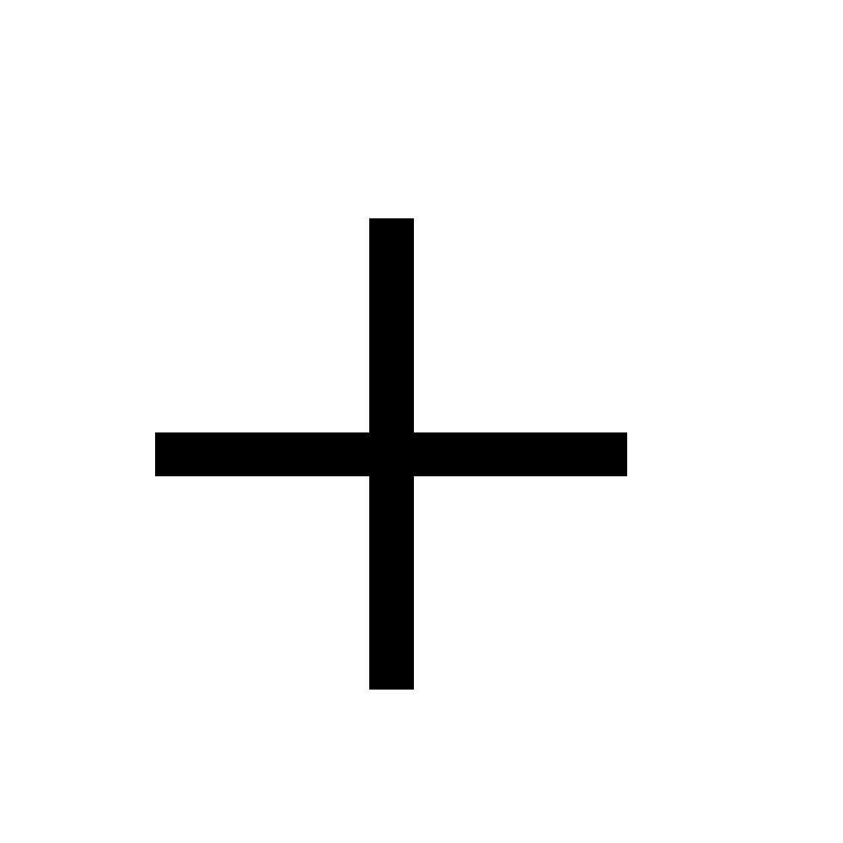, subtract , multiply and divide .
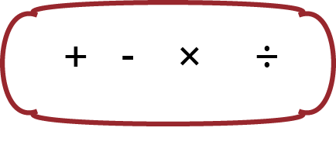
Figure 3: Four fundamental operators, add, subtract, multiply, divide
When writing Nemeth there is no need to put a blank space between the numbers (or alphabetic variables) and the operators. Literary Braille is already highly context oriented and Nemeth Braille is even more so. One way to remember not to put a space around an operator is to remember it has to do something, and we want to know what it is operating on.
__________ Operator Spacing __________
13+37
#13+37 ___________________________________________________________________________
You may also notice that in addition to leaving no space between the numbers and the addition operator, there is also no number sign before 37. We can do that because there was no space in front of 37 and it did not come after a grammatical mark.
The Nemeth Braille representations for add , subtract , multiply and divide are:

Print Character | Nemeth Braille
 | +
 | -
 | a*
 | _/
Table 16: Nemeth signs of operation
Here, the times symbol and the division symbol require two-cells. However, at higher levels of math the times symbol may be used interchangeably with the small dot, the dot product, or the cross product. There are specific rules regarding how to transcribe the variations depending on what kind of multiplication is meant. In most cases the two cell multiplication symbol shown above is the appropriate representation.
Drill 3. ___________________________ Write It __________________________________
Write the following in Braille.

100-50 25+45 3*12 15.25-4.25 32/6
-480+560 88/11 70*2 36-8+5 96/9-2
1+2-3+4-5 1180/10 1.5*4 35/7 19+1
___________________________________________________________________________

Drill 4. ___________________________ Read It __________________________________
Write the following in Print.
#4+0 #9-3 #5a*7 #8+2
#9-10 #33a*20 #80+77
#6a*8 #71+17 #100-18
#fe_/5 #59+46 #92a*46
___________________________________________________________________________

4.4 Punctuation
For our purposes today, we will make a distinction between the grammatical marks of literary Braille and punctuation marks. If the mathematical expression is part of a larger text, then we will have grammatical marks that relate to the text and we will need to use an indicator to separate the two. The punctuation marks, as referred to below, are grammatical marks being used as part of a mathematical expression.

Indicator | Braille Representation | Dot configuration
Punctuation | _ | dot 4-5-6
Nemeth decimal point | . | dot 4, dot 6
Table 17: Nemeth punctuation marks
______________ Separating Math from Grammatical Marks ______________
You then multiply by 5.
,you then multiply by #5_4

_____________________ and Punctuation Marks _____________________
5.25 slices of pie.
#5.25 slices of pie4
___________________________________________________________________________

Let’s break this down a little. Now that we are talking about more than stand-alone numbers, we need to apply a few more rules to make sure that we can use context to communicate which version of a Braille character we mean.
- Use the number sign when a number is preceded by a space. This includes instances where the number is the beginning of a line.
- Use the number sign when a number follows a grammatical mark. The exceptions are commas, hyphens and dashes. These do not require the number sign.
In simple equations this means that a number sign will appear at the beginning of the equation, but not before operators.
The last punctuation mark we’ll discuss is the mathematical comma , dot 6. Remember, this is different than the grammatical comma 1 dot 2 covered in Chapter 3. If you’ve already completed the uncontracted Braille exercises, you may recall that dot 6 is also the capitalization indicator. How do you tell them apart, you ask? Context.

Mathematical Comma
__________ Mathematical Comma __________
1, 3, 5 is a pattern.
#1, #3, #5 is a pattern4
___________________________________________________________________________

__________ Number Sign Omissions __________
X is the set 1,100-1,200.
,X is the set
#1,100-1,200_4
___________________________________________________________________________

There are two important things to highlight from the example above. Firstly, we can tell that the dots 2-5-6 at the end of the line represent a period because it is directly preceded by the punctuation indicator. Secondly, we were able to omit the number sign after the hyphen. As a reminder, we are able to use Nemeth numbers in these examples because they represent math or science information. It is not the list of numbers itself that lets us use Nemeth. For anything non-technical, we will always default to literary Braille numbers.

Drill 5. ___________________________ Write It __________________________________
Write the following in Nemeth Braille.

1,000,000 15.80 1908 -1912 323.121 6
1000, 999, 998, 997, 996, 994, 993
27-29 757 46-64 9.125 5, 15, 2017
___________________________________________________________________________

Drill 6. ___________________________ Read It __________________________________
Write the following in Print.

#345 #671 #100 #1066
-#50 #94 #8 #17 #965
#42 #523 #60 #12 -#9
___________________________________________________________________________

4.5 Signs of Comparison
An equation is not complete without a sign of comparison. Without a sign of comparison all we have is a mathematical expression. The most basic sign of comparison is the equals sign , which is another two character combination
.k (dots 4-6, dots 1-3).
You may even notice that this combination looks something like the print equals sign. That is a common feature of signs of comparison. Many of them are two character combinations that have a shape similar to the print character it represents. A simple example of these is
the greater than .1 and less than 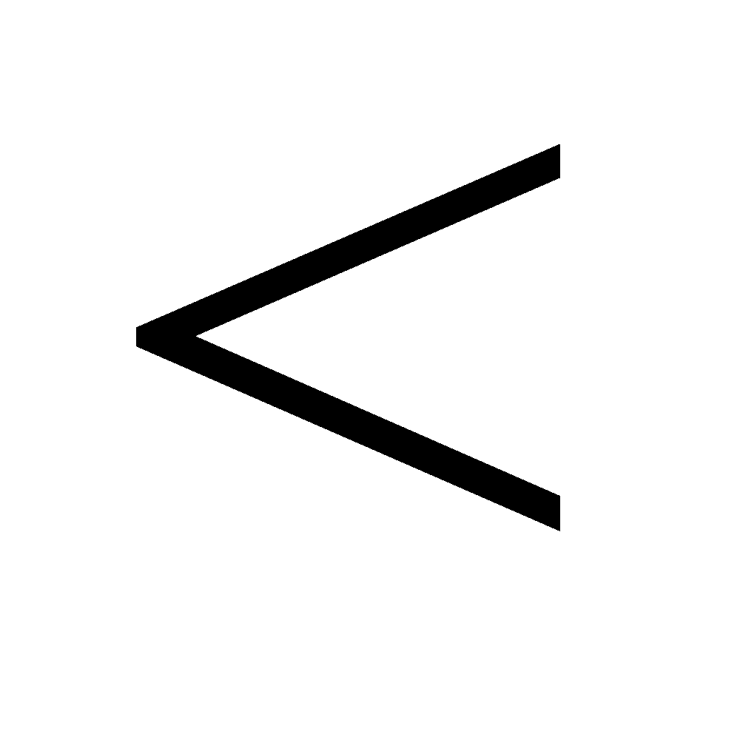 "k characters.
From here, there is just one more rule to know before you can begin writing simple Nemeth equations.
ALWAYS put a space before and after a sign of comparison.
Unlike operators, which should be placed directly next to the numbers and variables being operated on, we use spaces around comparators to help a Braille reader to know that one side of an equation is being compared to another one.
Print Character | Nemeth Braille
 | .k
 | "k
 | .1
Table 18: Nemeth Signs of Comparison
Now that you know basic syntax it is possible to transcribe simple equations. Do the following drill to practice. HINT: the rules about the number indicator still apply!

Drill 7. ___________________________ Write It __________________________________
Write the following in Nemeth Braille.

49 > 7 > 1
30 < 31
100/50*4 = 8
28-100+50 = -22
1.5 < 2.55
___________________________________________________________________________

Drill 8. ___________________________ Read It __________________________________
Write the following in Print.

#2+2 .k #4
#5+10 .1 #12+1
#7-20 .k -#13
#-.2+2.6 .k #2.8
#1250_/25_/5 .k #250
___________________________________________________________________________

4.6 Single Alphabetic Variables
Our last Nemeth topic is on variables. Although there are many multi-letter variables used in mathematics, if you can master the rules of single character alphabetic variable then you can easily extend it. To use alphabetic characters as variables in Nemeth code you just write them as you would in literary Braille with the capitalization indicator for capital letters. (Note: we won’t have any ALL CAPS when writing Nemeth.) That’s the power of using the lower-half of the Braille cell to represent numbers. Now we can write letters and numbers side-by-side without any extra indicators. Remember that the number indicator and punctuation indicator rules still applies, though.

Complete the practice drills.

Drill 9. ___________________________ Write It __________________________________
Write the following in Nemeth Braille.

a/b = c
y+15-2a = 2
Q*2r = 18
The answer is x = 45.
___________________________________________________________________________

Drill 10. ___________________________ Read It __________________________________
Write the following in Print.

,find x1 if #4x "k #8_8
#7 "k ,g
,a-30 .k #10_/a
s+st-t .1 ,r
___________________________________________________________________________

Chapter 5
Contractions
Grade 2 Braille or Contracted Braille uses contractions to speed up the reading and writing process. For example, in print it is common to see the words have and not, contracted to haven’t. Similarly, contractions in Braille exist for common words and common letter combinations. A complete list of contractions and the rules that govern them can be found in Braille Formats: Principles of Print-to-Braille Transcription, 2016. It puts UEB and a few American only transcription rules all in one place.
We can organize the contractions into two large categories: whole word contractions and part word contractions. Whole word contractions are 1, 2, or 3 cell Braille combinations that replace a whole word. For example, “every” becomes the single character ‘e’ and “receive” becomes the 3 character combination “rcv”. Part word contractions only simplify a group of commonly occurring letters, such as “ing” or “con”. Use of contractions is determined by the context of the letters, using rules of precedence.

5.1 Alphabetic word signs
The first thing to know about the whole word or what we’ll call alphabetic word signs is that the letters ‘a’, ‘i’, and ‘o’ do not have whole word contractions because they are themselves a word. Generally, whole word contractions are used when the word stands alone, meaning it is preceded and succeeded by a space.

Punctuation | Braille Representation | Dot configuration
b | b | but
c | c | can
d | d | do
e | e | every
f | f | from
g | g | go
h | h | have
j | j | just
k | k | knowledge
l | l | like
m | m | more
n | n | not
p | p | people
q | q | quite
r | r | rather
s | s | so
t | t | that
u | u | us
v | v | very
w | w | will
x | x | it
y | y | you
z | z | as

Table 19: Whole word, single cell, alphabetic contractions.
Let’s practice.

Drill 1. ___________________________ Write It __________________________________
Write the following sentences in Braille.

You can eat more ravioli, but you might not like it Joey.
Please pass the donuts; we just like sprinkles.
Boy! He's quite a party animal.
___________________________________________________________________________

Drill 2. ___________________________ Read It __________________________________
Write the following sentences in Print.

please take x z is l x or n8
c y check e line for errors8
we're r busy j now2 go away4
___________________________________________________________________________

5.2 Non-alphabetic Whole Word Contractions
From here the whole word contractions continue. There is a set of non-alphabetic whole word contractions for the following common words:

Word | Braille Representation | Dot configuration
and | & | dots 1-2-3-4-6
for | = | dots 1-2-3-4-5-6
of | ( | dots 1-2-3-5-6
the | ! | dots 2-3-4-6
with | ) | dots 2-3-4-5-6
Table 20: Non-alphabetic whole word contractions.

In UEB, these are specifically referred to as strong contractions.

Now is the time when your contracted Braille cheat sheet can really come in handy for keeping track of all you’ve learned. Use the one, you’ve been given to transcribe the following:

Drill 3. ___________________________ Write It - BONUS ____________________________
Write the following sentences in Braille.

You can eat more ravioli and you might not like it Joey.
Please pass the donuts with the sprinkles.
Boy! He's quite a party animal where he's from.
___________________________________________________________________________

Drill 4. ___________________________ Read It - BONUS ____________________________
Write the following sentences in Print.

,take x z is & l x6
,check e line please4
,we're r busy ) chores4
___________________________________________________________________________

6
Tactile Graphics
Understanding the foundations of Braille and Nemeth Braille are critical to having a good introduction. But no introduction would be complete without some basics on the representation of images. Before explaining any of the technical details, it is important to consider the different ways in which the blind and sighted process graphical information, so that you can create a useful, touchable version of the image called a tactile graphic. While no generalization can completely capture the unique way individuals think and perceive the world, roughly speaking sighted individuals use whole-to-part processing and blind individuals use part-to-whole processing. That means a sighted individual tends to take in the large view before focusing on the specific parts of it that are relevant to the text. Blind individuals tend to use touch and auditory means to grasp the individual parts of an image and from it generate the complete view.
For example, consider an apple in a tree like the figure
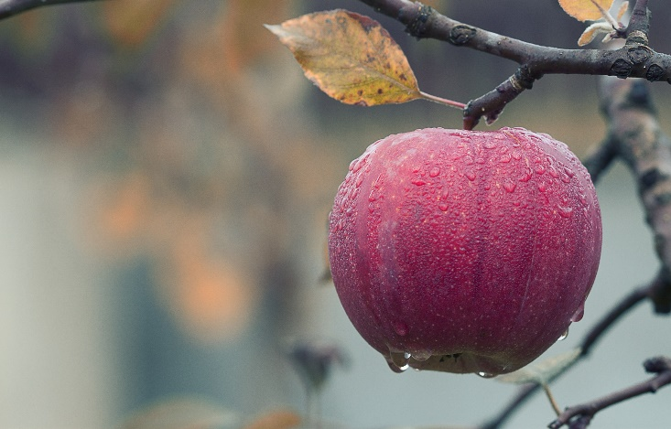
Figure 4. apple in a tree by Mircea Plosca (pixabay.com)
A sighted person might see an apple in a tree, but someone reading a tactile graphic has to determine that the long solid lines are in fact a branch from which a round object is hanging, therefore it’s an apple in a tree. The difference is subtle but vitally important when developing tactile graphics.
How then do you turn pictures into something that can be felt? The first step in any graphic transcription is to determine what the figure is trying to convey. While book graphics are often designed to be eye-catching, for transcription, graphics need to be stripped down and simplified. You may even determine the graphic does not need to be transcribed. If a graphic is only present to add interest or decoration and does not convey a crucial concept, it might be more appropriate to omit the figure and add a transcriber’s note describing the graphic in the Braille text. Additionally, some graphics may not even be appropriate to represent in a raised-line, two-dimensional format. In such cases, it is best to consider three-dimensional models or text descriptions.
After deciding a 2-D tactile is genuinely needed, it is important to realize that tactile graphic transcription is not a one-to-one translation. Excellent guidelines on the transcriptions of graphics are available from BANA in the Guidelines and Standards for Tactile Graphics. The guide contains very specific advice on the proper use of texture, pattern, width, and spacing to develop tactile alternatives. To leverage these standards, a transcriber must decide what may need to be kept, changed, or omitted in order to represent the same content in Braille. Some common examples of graphics that require changes for tactile representation are:

- Graphics where color is used to differentiate regions or help the reader interpret the graphic’s content (i.e., maps)
- Graphics containing large amounts of text that cannot fit on a tactile graphic (i.e., heavy annotations)
- Graphics where layers of meaning are conveyed (i.e. shadows used to represent moving objects)
- Graphics shown in three-dimensions that can be drawn in two-dimensions
- Graphics which need Braille labels even though no labels are present in print (i.e., anatomy, astronomy)

Several different methods can be used to create tactile graphics. Two of the simplest ways are using tactile diagramming kits such as the Wheatley Tactile Diagramming Kit, or making Swellform graphics, also known as “Picture in a Flash.” Swellform graphics involve drawing or printing on special paper that is run through a heater that activates the paper and ink, causing it to swell and become tactile. Other forms of tactile graphics include Tiger Tactile graphic, created with vector graphic software like Tactile View or Adobe Illustrator, or thermoform graphics using master models and vacuum sealing.

6.1 Tactile Graphic Best Practices
While BANA has a thorough set of guidelines, when starting out we have several rules of thumb that may be useful. These are not necessarily hard and fast rules, but best practices that are well established among transcribers 1) be consistent 2) bigger is better 3) simplify 4) ask your reader for feedback.
Consistency will decrease the time it takes to make graphics, especially when they are part of a textbook. We highly recommend having a file that contains many of your commonly needed shapes and objects. When you are able to produce the same shapes that have the same meaning in a consistent manner, it will help the reader to interpret them correctly and in progressively less time.
For example, lines used to show distance can be a long line with flat ends, a long line with arrowhead ends, or the combination. Even though a textbook or manual may switch back and forth between these, if there is nothing in the text that gives specific meaning to the type of end a distance line has, we recommend picking one and using it consistently. If you do this, you must add a transcriber’s note to the volume that says you have done this.
In Braille, size truly matters. Braille font is approximately the equivalent of a 30 point font for comparison⎯ nearly 3 times as large. The graphic representations should do the same, be roughly 3 times as large as the print graphic. This increase in size is often directly relevant to the next best practice, simplification.
Simplification is critical. The fingers do not take in as much detail as the eyes, thus simplification in the generation of tactile graphics helps to ensure accurate interpretation and requires less time and energy on the part of the reader. Simplification takes many forms, but a few common changes may be replacing colors with Braille labels, producing a 3D view of an object in profile, and adjusting the location of labels to avoid excessive overlapping lines.
Lastly and perhaps most important, if possible request feedback from the reader. Just like learning to read and write Braille, learning to read tactile graphics is a skill that someone must learn over time. While some Braille readers are quite adept at interpreting tactile graphics, some have an extremely difficult time forming the connection between the flat representation and the physical object or concept being communicated. In fact, some Braille readers may prefer manipulatives and find tactile graphics too laborious to interpret to be a valuable resource. When regular feedback from your reader is available, take advantage of it.

6.2 Tactile Graphic Translations
Even with the BANA guidelines and transcriber best practices, there is no perfect method for creating tactile graphics. It is part art and part science, requiring time and practice. On top of which, transcribers should avoid interpreting the graphics. But in order to achieve the best practices above, we highly recommend two changes that a transcriber can regularly make which do not hinder the reader or the integrity of the tactile graphic.

Overlapping paths
The raised line drawing which makes up a tactile graph should use a variety of line textures when needed using a simple to complex progression as outline in the Guidelines and Standards for Tactile Graphics. Using outlines as an example, always start with the simplest form thin solid lines. From there adjust thickness before line texture, because solid lines are easier to follow. After that dashed lines and thick dashed lines can be used.
A word of caution though, after about four different line textures, especially with overlapping paths, the lines can become impossible to follow. We recommend using a thin line for less important information and a thick line for the path or point of interest. We also recommend limiting line types to: solid, dashed, or dotted. While BANA allows many more variations, we have found that these are different enough to produce and interpret consistently. While we used line type as the example, these ideas also apply to the fill of shapes.
When the number of overlapping paths cannot be transcribed using the method described above, consider showing paths side-by-side or on separate pages. It is acceptable to use multiple pages and/or multiple graphs to represent the graphic as long as this is clearly conveyed to the reader. Additionally, to help the reader reconstruct the figure mentally be careful to maintain the size and orientation of the base figure on the physical page.

Additional Labels
As alluded to earlier, another effect of the part-to-whole processing of a blind reader is the need for additional labels not present in the print graphic. This is especially helpful when trying to convey objects that are unusual, divided, or only partially shown. Some examples are a hand holding an object or a table where only one leg is shown in print. If the hand isn’t necessary, it could be replaced with a transcriber’s note or labeled. If only one leg of a table was shown, for clarity a transcriber could simply label the object “table” or show the missing leg to avoid confusion. Adding labels is also important where objects of a similar size and shape have different meanings, such as compound diagram for chemistry, or when the graphic is from a bird’s eye view.

7
Hard Copy Braille Transcription Basics
Congratulations! You are ready to start transcribing your first text into uncontracted Braille. There are a few hard copy Braille transcription tips you need to know before you start.
- We’re only covering the basics: there is a manual for print-to-Braille transcription in Braille Formats: Principles of Print-to-Braille Transcription
- These materials are for instructional purposes and cannot replace the full requirements of certification. For more information, review the resources from NFB.
Here is what you do need to know about hard copy Braille for today. Firstly Braille paper is large. Let me repeat that: LARGE. For every 1 page of print information it will take 3 to 5 pages of Braille to reproduce it. That’s after using contractions!

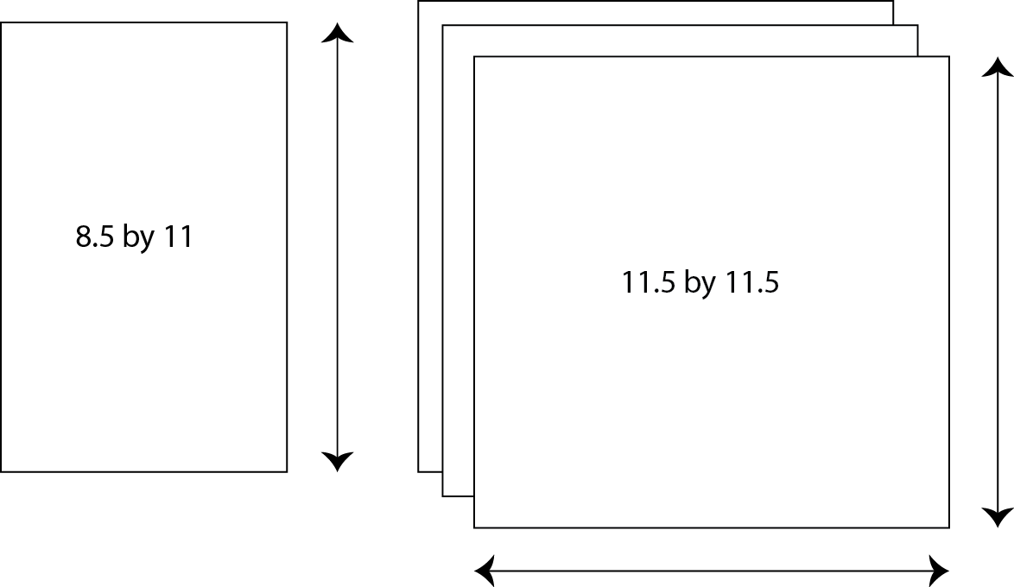
Figure 4: Visual comparison of print paper versus Braille paper

Why the 3-5 range? One reason is not all embossers are equal. The embossers (Braille printers) we will use today can emboss on both sides commonly called interpoint.

The last formatting tidbit you need is indentations. In Braille we do not use a blank line between paragraphs the way we do in print. Instead, we indent the beginning of each new paragraph by 2 Braille characters. For the books we will transcribe today, we will consider each page its own paragraph. Below is an example.

__________________________________ Print Text __________________________________

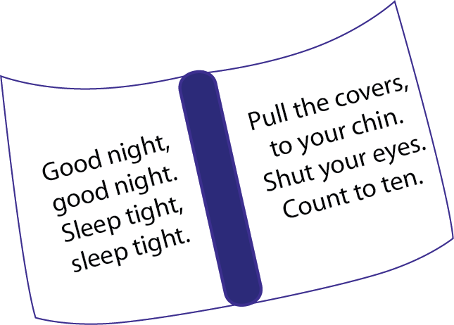

Figure 5: Pretend children’s bedtime book
______________________________________________________________________________
__________________________________ Braille Text __________________________________

Figure 6: The children’s bedtime book in Braille
______________________________________________________________________________

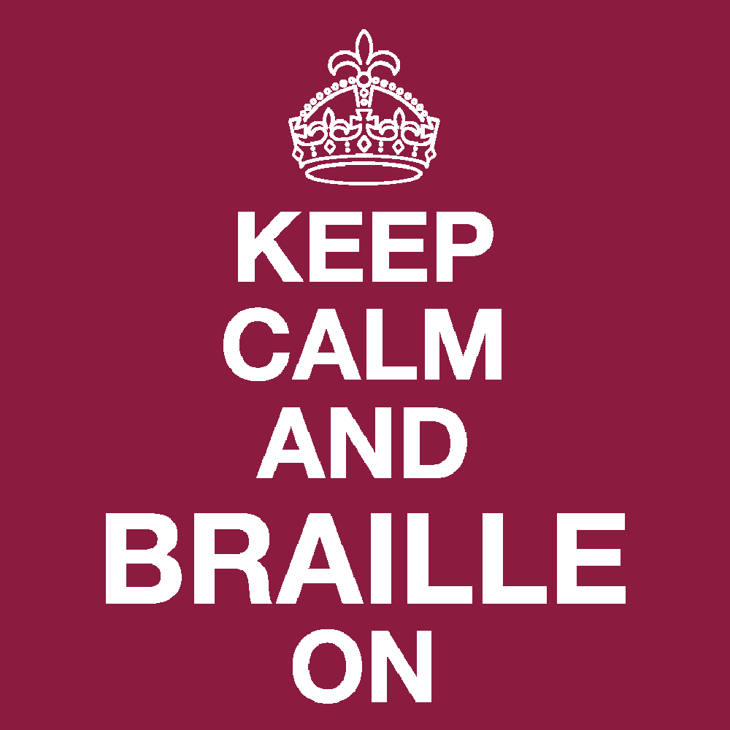

Congratulations on completing the Braille Bootcamp! You should feel extremely proud of all you accomplished today. If you enjoyed it and want to continue learning on your own check out UEB Online.

Appendix Solutions

Chapter 3 Braille Alphabet and Numbers

Drill 1
Cab dab had jig gad fade fad egg high ad
Fed big jibe bad hi ace dig cage if face

Drill 2
cafe babe acade egad
deface beef age iced
a fee dice jade high

Drill 3
Slots lost rook stop noon not knoll look
Most pomp loom knot moor storm torn room

Drill 4
nook slot posts root
Morn moons tort torn
Solo loss rooms knot

Drill 5
Vexed waxy zero bundt under woven lulled
Xebec exit vote zoo fixed blaze worn yak

Drill 6
yolk swig wombat lox
swoon lovely mix why
swan wizened pew nix

Drill 7
Bad beef bide cadge cab lice decide free
Deface die egg mole fife feet goes stone
Fig gab exit hide idea ice jade jigs joy
Badge decide beg dad dig when abide acid
Farce quick bad beef dances jib home bed

Drill 8
cornice empire italian clock
ridge work comes thoroughness
pretty blue anemone in water
an unbelievably quiet poodle

Drill 9
#ef pigs dug #gc holes in #i garden beds
He ate #aej pickled peppers in #bf meals
#ajjj ridges on #dh mountains in #h days

Drill 10
835 pages 2 dashes
traveling 100 miles
laughter 875 times now

Drill 11
My naughty cow was locked in pen #c too4
Gabby and I ate #h ice cream sandwiches4
#ab hair stylists cut1 curl1 and tease4

Drill 12
4 red, wax candles.
where are 2 bells?
she steps; he waits.
you: work then play!

Drill 13
Well,-they could watch jackson's movies4
Self-reliance or 8independence0 grows4
What444 .<coughing.> it's strep throat8

Drill 14
play ball—or dance.
what's up with them?
seriously! what now!

Drill 15
,hi my name is ,erin ,ho4 ,what's yours8
,actor ,ethan ,shewl is a self-made man4
,the new sign says3 #be percent ,,sales4

Drill 16
See item No. 451.
Yay! We won chips.
Aaron is an INFP.

Chapter 4 Nemeth Code Braille

Drill 1
#1 #20 #35 #50 #75 #901 #467 #281 #34 #8
#7 #101 #24 #65 #3 #873 #26 #85 #1215 #9
#83 #205 #14 #4 #91 #30 #100 #57 #107 #8

Drill 2
345 671 100 1066
500 94 8 17 965
42 523 600 12 9

Drill 3
#100-50 #25+45 #3a*12 #15.25-4.25
-#480+560 #88_/11 #70a*2 #36-8+5
#1+2-3+4-5 #1180_/10 #1.5a*4 #35_/7

Drill 4
4+0 9-3 5x7 8+2
9-10 33x24 80+77
65/5 59+46 12x4

Drill 5
#1,000,000 #15.80 #1908-1912 #323.121 #6
#1000, #999, #998, #997, #996, #994, #993
#27-29 #757 #46-64 #9.125 #5, #15, #2017

Drill 6
345 671 100 1066
-50 94 8 17 965
42 523 60 12 -9

Drill 7
#49 .1 #7 .1 #1
#30 "k #31
#100_/50a*4 .k #8
#28-100+50 .k -#22
#1.5 "k #2.55

Drill 8
2+2 = 4
5+10 > 12+1
7-20 = -13
0.2+2.6 = 2.8
1250/25/5 = 250

Drill 9
a_/b .k c
Y+15-2a .k #2
,qa*2r .k #18
the answer is x .k #45_4

Drill 10
Find x, if 4x < 8?
7 < G
A-30 = 10/a
s+st-t>R

Chapter 5 Contractions

Drill 1
,Y c eat m ravioli1 b y might n l x ,joey4
,Please pass the donuts2 we j l sprinkles4
,Boy6 ,he's q a party animal4

Drill 2
please take it as is like it or not?
can you check every line for errors?
we're rather busy just now; go away.

Drill 3
,y c eat m ravioli & y might n l x ,joey4
Please pass ! donuts ) ! sprinkles4
,Boy6 ,he's q a party animal where he's f4

Drill 4
Take it as is and like it.
Check every line please.
We’re rather busy with chores.

